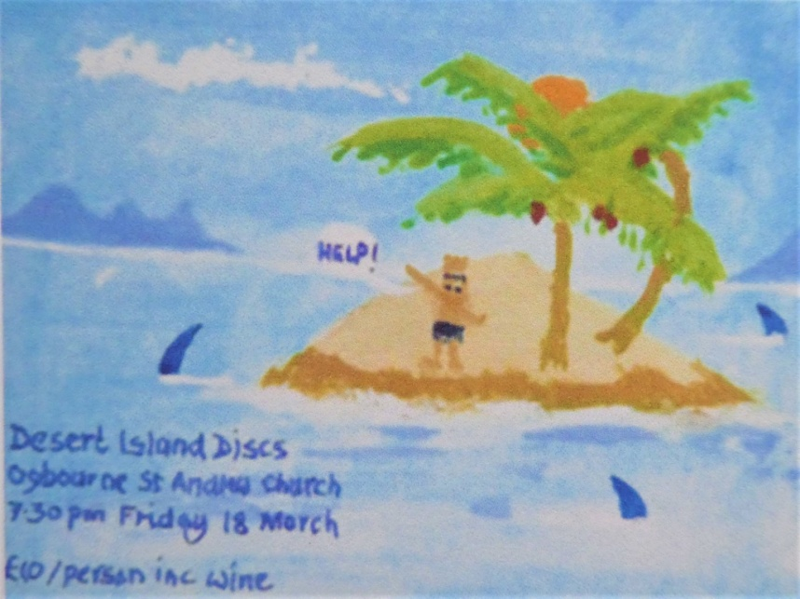

**DESERT ISLAND DISCS with SID VINCENT**

at Ogbourne St. Andrew Church

Friday 18th March 2022 at 7.30pm

An evening with Sid Vincent, who will share his choice of eight discs

and talk about his varied life as an ex-policeman, gamekeeper, dog

trainer, Marlborough Summer School course teacher and his passion

for nature.

Tickets : £10.00 (incl. a glass of wine)

Tickets available from :

Roger Swan (01672-841322 or rogerfrederickswan@hotmail.com)

Marion Gordon-Finlayson (01672-512125 or maizey50@gmail.com)