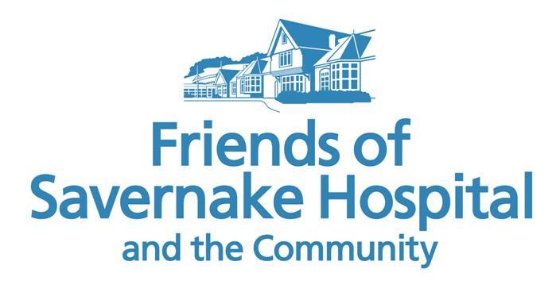
December 2021 Newsletter from the Friends of Savernake Hospital and the Community
Every Christmas for the past few years, I have sent a newsletter on behalf of the Friends trustees. This provides a round-up to members, volunteers and grant applicants of the work of the Friends over the previous 12 months.
Before starting to write, I always look at my previous year’s newsletter. My 2020 newsletter focussed on the work of the NHS during the first year of the pandemic; how the Friends had supported the efforts of local health professionals; and how the local community had donated and raised funds – in turn – to support the work of the Friends. There was no doubt that my newsletter for 2020 was written at a time of great worry and uncertainty due to Covid.
As this year comes to an end, I would like to focus on a number of positives and achievements over the past year to take us all into 2022.
Re-opening the Shop
Probably our greatest success this year was the re-opening of the Savernake Hospital Shop in October. Shut since March 2020, our new Shop Coordinator, Ian Philpott, who was appointed in August, has moved mountains (as well as a lot of Shop equipment and stock) to enable the Shop to open again for 3 hours each weekday between 10am and 1pm. The preparatory work for the re-opening was significant – not just re-stocking the Shop and Trolley virtually from scratch, but the careful and thorough consideration of all the new procedures to protect volunteers and customers from Covid, including a thorough deep-clean of the Shop and the installation of a new “sneeze screen”.
However, the immense efforts were worth it – and we had an official re-opening of the Shop on 18 October, with the cutting of the ribbon by myself and Co-Chair, Pat Harper. (However, please do not be alarmed by the photo of us both which appeared on Facebook, brandishing scissors; this was a very amicable event – not a case of “scissors at 20 paces”!)
We are delighted that five new volunteers have come forward since August to join the team. They have now completed their training. So, a warm welcome to Mary, Pam, Marie, Liz and Christine!
Since re-opening the Shop, we have also seen the Trolley return to Ailesbury Ward, with the full support of the nursing staff.
Now that the Shop has re-opened, we are planning for next year. You may be aware that Savernake Hospital is no longer issuing hearing aid batteries. So, we are currently making enquiries as to whether the Friends – through the Shop - could stock them instead. There are a number of administrative hoops that we still need to jump through – but we feel that this is a much-needed service and would provide support to the hospital’s Audiology Department. If we are successful, we will, of course, publicise this on Facebook and in the local media. Watch this space ….
Zoom AGM 2021
After having had to cancel our 2020 AGM, we held our 2021 AGM via Zoom in September. Computer frustrations aside, I would have preferred to be able to see some of our members in person and to share our news over tea and cake. However, we took the view that, at least for now, Zoom was the safer option.
Zoom meetings require an entirely new “etiquette”, including sharing screens rather than simply passing paperwork around a room. For me, lighting proved an issue, - so for other attendees (with some amusement) I appeared on screen as a rather sombre silhouette.
At the AGM, Liz Wright, our Treasurer, was unanimously re-elected, as was Lorna Hamzah – both invaluable trustees. I have been co-opted for another year, and continue to share the responsibilities of Chairman with Pat. However, again, I do make a plea for more trustees to join and help us consider grant applications and attend (just) 4-5 committee meetings each year. We value a variety of insights from our trustees. It is not necessary to have a background in healthcare – just a keen interest in supporting those in the local community suffering from illness and disability – and of course, not just physical illness but SEN, mental disability and matters affecting emotional well-being.
2021 Grants
This year we have provided a grant of £10,000 towards a CT scanner to be used in the new Radiotherapy Unit at GWH, due to open in 2022; gardening supplies for the patients’ Enterprise Group at Cotswold House (the adult eating disorder unit at Savernake Hospital) and funding for Marlborough St Mary’s for a secure play area for their SEN pupils. We have also provided funding to Burbage Surgery for the installation of a Covid-friendly dispensing window.
Most recently, we have provided a grant of £2790 to Marlborough Medical Practice for a doppler machine. This follows a grant a couple of years ago for a similar machine at Pewsey Surgery which has improved the treatment of leg ulcers as well as reducing the treatment time. Staff at Marlborough Medical Practice have been delighted to receive the grant so that they can provide the same service in Marlborough as in Pewsey.
We have also been pleased to hear that Kennet Community Transport were finally able to take delivery of their new minibus a few months ago after production delays. As you may recall, the Friends provided a grant of £10,000 towards the new minibus in late 2020. In return, our logo can be seen on the side of the vehicle in recognition of our support. But what is even more pleasing is to see it parked outside the Jubilee Centre (open again), delivering older members of the community for lunch and a chance to catch up with others.
Christmas Gifts 2021
We are all approaching Christmas rather cautiously this year, and are all hoping that it is more “normal” than last year, and that it will indeed allow for friends and family to meet in person. For those who will be spending Christmas as patients in Savernake Hospital, the Friends will – as we do every year - be distributing gifts and cards around Christmas Eve. This is something I very much enjoy organising (and indeed little gifts have already been selected and wrapped!). I may not be able to deliver the gifts in person, but our very best wishes go out to all those patients who cannot be home this Christmas.
Thank you
I would like to thank our members and fellow trustees for your support over the past year. Thanks must also go to Marlborough Mayor, Councillor Mark Cooper for supporting the Friends for a second year as one of his chosen charities, and to Tesco and Waitrose. It is with this combined support that the Friends have been able to fund grants for those suffering from ill-health and disability in the local community and Savernake Hospital, and to support local health professionals.
On behalf of all the Friends trustees, I wish you all the best for the 2021 Christmas season - and I hope you enjoy the newsletter – please let me know.
I hope that we can meet face to face at our next AGM over tea and cake in 2022.
Kind regards

Janet Louth
Co-Chair Friends of Savernake Hospital and the Community
Telephone 01672 513868
jlouthmarlborough@gmail.com

