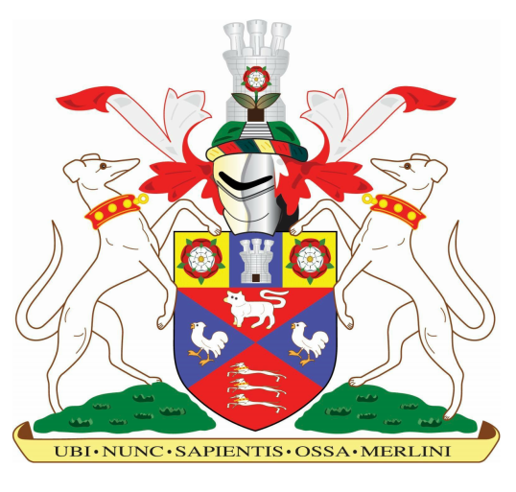
Marlborough History Society
www.marlboroughhistorysociety.co.uk

"Rediscovering the Old Palace of Westminster in the Sixteenth Century"

By Dr Elizabeth Biggs

The Palace of Westminster, seat of government and royal residence from the time of the Normans through the Tudors, is well known to enthusiasts of the period (not to mention the Wolfhall Trilogy).

Dr Elizabeth Biggs is a scholar of the medieval period, who is interested in the intersections of political, intellectual and religious culture in late medieval and early modern England and Ireland.

She has a particular interest in the Chapel of St Stephen, within the Palace, and has recently published a book on the subject.

Thursday, 20 January, 7:30 pm, St Peter’s Church.
Guests are very welcome, £5 entry.
(Covid safe provisions are in place)

