Philip Wilkinson is doing a last call for people to take part in his survey ahead of it closing on Monday 22 November.
The feedback received from the public, stakeholders and commissioned services will help shape the priorities he sets for the next four years.
Kind regards,
Zara
Time is running out to have your say on PCC's policing priorities
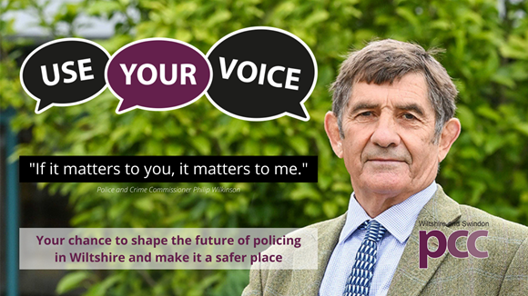
Download

There are only a few days left to have your say on what priorities PCC Philip Wilkinson should set for Wiltshire Police and his office to make Wiltshire safer.
Part of the PCC’s role is to produce a Police and Crime Plan for the county. It’s a blueprint for the strategic policing and crime priorities for the next three years.
As this current plan comes to an end by March 2022, the new Plan will start immediately afterwards.
It sets out how the PCC’s pledges and priorities will be delivered throughout Wiltshire but more importantly it should reflect the needs and priorities of all our communities too.
What you say will directly influence Wiltshire Police’s priorities, objectives and activities. The new Police and Crime Plan will ensure both the force and the PCC’s office are working towards the same goals in a joined-up, co-ordinated, approach.

Use Your Voice
Complete the survey online. (Please click on 'online' and it will take you straight to the survey) or you can use this link:
Use Your Voice survey link
If you are having trouble accessing the online survey or need this in an alternative format or language, please contact us. The survey is also available in paper format on request. Please email pcc-consultation@wiltshire.police.uk

Other ways to get involved
You can email your thoughts around policing priorities. Please email: pcc-consultation@wiltshire.police.uk or send us a message on Facebook or DM us on Twitter

Events
After the plan has been drafted, the PCC will be holding debates and discussions at numerous events and stakeholder group meetings. He will be looking for your feedback.
We will update all events on the Use Your Voice website page once definite dates have been arranged. This will be during December and January before the final draft is presented to the Police and Crime Panel in February.
You will also be able to download the draft Police and Crime Plan, once produced, from the website and provide your feedback and comments to us.
Thanks - we can't wait to hear from you!
Contact Information
Zara-Ann Prendergast
Campaign and Communications Manager
Wiltshire and Swindon OPCC
07586496070
Zara-ann.prendergast@wiltshire.police.uk

