What to put in your Grab Bag

- A small first aid kit and medication
- Copies of important documents in a waterproof bag
- Copies of prescriptions for regular medication
- A battery torch with spare batteries or a wind up torch
- A battery radio with spare batteries or wind up radio
- Bottled water and some non-perishable emergency foods
- Childcare supplies or other special care items
- Notebook with pen and pencil
- Toiletries and sanitary supplies
- Infant supplies
- Spare clothes
- Spare sets of keys
- Mobile phone and charger
- Spare money
- Spare contact lenses or glasses
- Hi-vis jackets or tabards
- Some warm clothes or blankets
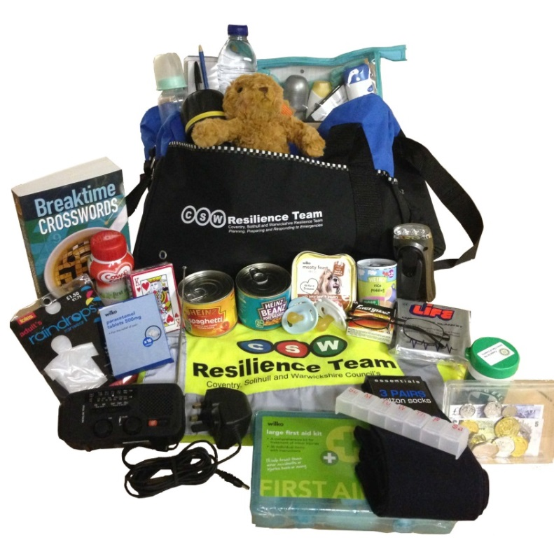
- Any other items that might provide some comfort if you have to leave your home in a hurry

